Project Report on GSM and Call Flow
Under the guidance of
Mr. R.K. Sharama
Head Core Networking
MTS India

GSM : Global System for Communication

Definition:
It is a standard by European Telecommunications Standards Institute which is use to provide the method for second generation cellular networks. Second generation digital networks are ued as a replacement for first generation cellular networks. It is basically a circuit switched netwrk optimized for full duplex voice telephony.

Architecture
The GSM network can be broadly divided into:
- The Mobile Station (MS):It is the mobile phone which consists of the transceiver, the display and the processor and is controlled by a SIM card operating over the network.
The MS consist of two parts:
- IMSI:The International Mobile Subscriber Identity or IMSI /ˈɪmziː/ is used to identify the user of a cellular network and is a unique identification associated with all cellular networks. It is stored as a 64 bit field and is sent by the phone to the network.
- IMEI:The International Mobile Equipment Identity or IMEI /aɪˈmiː/ is a number, usually unique, to identify 3GPP and iDEN mobile phones, as well as some satellite phones.
- The Base Station Subsystem (BSS): It acts as an interface between the mobile station and the network subsystem. It consists of the Base Transceiver Station which contains the radio transceivers and handles the protocols for communication with mobiles.
The BSS is composed of two parts:
- The Base Transceiver Station (BTS): The BTS houses the radio transceivers that define a cell and handles the radio link protocols with the MS. In a large urban area, a large number of BTSs may be deployed.
- The Base Station Controller (BSC): The BSC manages the radio resources for one or more BTSs. It handles radio channel setup, frequency hopping, and handovers. The BSC is the connection between the mobile and the MSC.

- The Network Switching Subsystem (NSS): It provides the basic network connection to the mobile stations. The basic part of the Network Subsystem is the Mobile Service Switching Centre which provides access to different networks like ISDN, PSTN etc.
- Mobile Services Switching Center (MSC): The central component of the Network Subsystem is the MSC. The MSC performs the switching of calls between the mobile and other fixed or mobile network users, as well as the management of mobile services such as registration, authentication, location updating, handovers, and call routing to a roaming subscriber.
- Home Location Register (HLR) : The HLR is a database used for storage and management of subscriptions. The HLR is considered the most important database, as it stores permanent data about subscribers, including a subscriber's service profile, location information, and activity status.
- Visitor Location Register (VLR) : The VLR is a database that contains temporary information about subscribers that is needed by the MSC in order to service visiting subscribers.
- Equipment Identity Register (EIR) : The Equipment Identity Register (EIR) is a database that contains a list of all valid mobile equipment on the network, where its International Mobile Equipment Identity (IMEI) identifies each MS.
- Authentication Center (AuC) : The Authentication Center is a protected database that stores a copy of the secret key stored in each subscriber's SIM card, which is used for authentication and ciphering of the radio channel.
- The Operation Support Subsystem (OSS): It is used for Operation and Maintenance Center. All kinds of alarms generated as well as various faults are detected and troubleshooted via Operation and Maintenance Center.
The operations and maintenance center (OMC) is connected to all equipment in the switching system and to the BSC. The implementation of OMC is called the operation and support system (OSS).

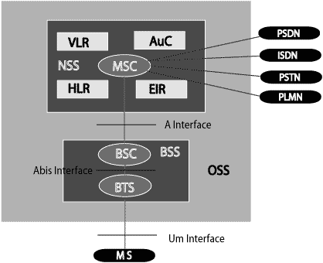

The additional components of the GSM architecture comprises:
- SMS Serving Center (SMS SC)
- Gateway MSC (GMSC)
- Chargeback Center (CBC)
- Transcoder and Adaptation Unit (TRAU)

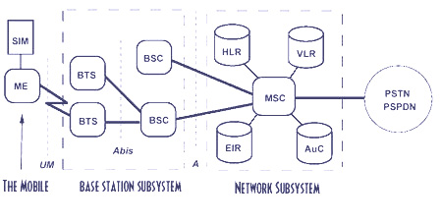

Call Setup
1.When a subscriber initiates a call by dialling a number in his mobile it directly send a request to the BTS which he comes under.
2.BTS there by sends the request to the BSC to which it is connected.
3.From the BSC the request is made to the MSC to which it is connected.
4.Then MSC sends a request to the HLR to check the information about the caller like account balance(if pre paid),live user,area of the caller etc.
5.After checking all the details the HLR sends a acknowlegement message to the MSC that the caller is O.K. to make a call or not.
6.If that message is O.K. the operation continues or else the MSC sends a NOT O.K. message to the BSC which has made the request and BSC to the BTS and BTS to the Mobile.At the next instance the call get disconnected.
7.If the message recieved by the MSC is O.K. then it again sends a request to the HLR to find the called party(the subscriber to whom call is made).
8.The called party and the caller may comes under the same MSC or different MSC.If both comes under the same MSC then the HLR finds the subsciber easily and informs the MSC that to which area the called party belongs.The MSC therefore establishes a air link between the both parties.Thus the call gets connected.
9.If both parties comes under different MSC then the HLR again search for the MSC to which the called party belongs and inform the same to the MSC of the caller.Thus the MSC of the caller establishes a air link between the both parties.Thus the call gets connected.
After the call gets disconnected the Billing is made the Billing Server which is present in the HLR.

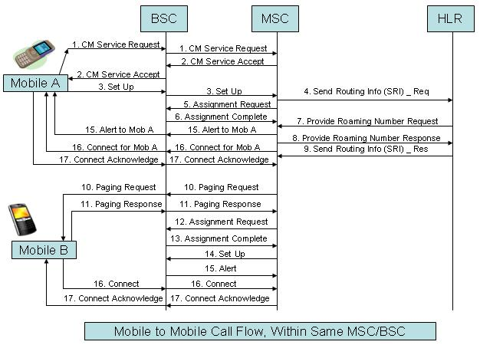
Submitted by:
Divyanshu Shukla
UPTU
CSE
Lucknow

